**API in NodeJs**

Create a class "Fruit" with the following fields: id, name, color

OUTPUT:-

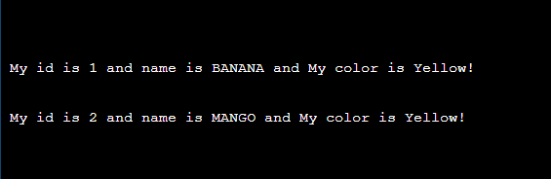

Create an API that will return a sorted List of "Fruit" objects based on color

OUTPUT :

